**Public transportation optimization**

**Phase 3: Devlopment part 1**

**AI & ADS:**

**Data Integration:** Collect and integrate data from various sources, including traffic sensors, GPS, weather, and passenger information, to provide real-time data for AI and ADS to make informed decisions.

**AI-Based Traffic Management:** Implement AI algorithms to manage traffic flow, reduce congestion, and optimize routes for public transportation vehicles, including buses and trains.

**Vehicle-to-Infrastructure (V2I) Communication:** Enable vehicles to communicate with infrastructure, such as traffic lights and road signs, to enhance safety and traffic flow.

**Fleet Management:** Utilize AI for efficient fleet management, including maintenance scheduling, predictive analytics for breakdowns, and optimizing vehicle deployment.

**Passenger Experience:** Enhance the passenger experience with AI-driven services like real-time updates, ticketing, and interactive trip planning**.**

**DAC:**

**Decentralized Control:** Implement DAC systems that allow individual vehicles or components to make decisions autonomously, reducing the need for centralized control.

**Vehicle-to-Vehicle (V2V) Communication:** Enable vehicles to communicate with each other to coordinate movements, share information about road conditions, and avoid collisions.

**Real-time Data Sharing:** Utilize decentralized data-sharing platforms to enable vehicles to share information about traffic conditions, passenger loads, and route options.

**Dynamic Routing:** Implement algorithms that allow vehicles to adapt their routes in real-time based on changing traffic conditions and passenger demand.

**Adaptive Scheduling:** Use DAC to create adaptive schedules for public transportation vehicles, allowing them to respond to passenger demand dynamically.

**Fault Tolerance:** Ensure that DAC systems have built-in fault tolerance mechanisms to handle failures or disruptions in individual vehicles or components.

**Energy Efficiency:** Optimize the energy consumption of public transportation vehicles by enabling them to make decisions that reduce fuel consumption and emissions.

**Safety Measures:** Implement safety features in DAC systems, such as collision avoidance and emergency response protocols.

DAC technology has the potential to revolutionize public transportation by creating more flexible, efficient, and adaptive systems. It can lead to reduced congestion, improved passenger experiences, and greater sustainability in urban transportation networks.

**IOT:**

**Real-time Tracking:** IoT sensors on buses, trams, and trains can provide real-time location data to passengers via mobile apps, reducing waiting times.

**Predictive Maintenance:** IoT devices can monitor the condition of vehicles and infrastructure, enabling proactive maintenance to prevent breakdowns and delays.

**Smart Traffic Management:** IoT can be used to optimize traffic signals and routes to reduce congestion and improve traffic flow.

**Fare Collection:** Implementing contactless payment systems using IoT can streamline fare collection and enhance convenience for passengers.

**Passenger Information:** IoT can provide real-time information on schedules, delays, and route changes, keeping passengers informed.

**Safety and Security:** IoT can enhance security with video surveillance, emergency buttons, and sensors for accident detection.

**Environmental Monitoring:** IoT can help track emissions and reduce the environmental impact of public transportation.

**Analytics:** Collecting and analyzing data from IoT sensors can lead to insights for further optimization.

Implementing these IoT solutions can make public transportation more efficient, convenient, and sustainable.

**CAD:**

**Route Planning:** CAD software helps in designing efficient transportation routes, taking into account factors like traffic flow, stops, and accessibility.

**Infrastructure Design:** CAD can be used to design transportation infrastructure such as bus stops, transit hubs, and transit lanes, ensuring they meet safety and accessibility standards.

**Vehicle Design:** CAD aids in designing and modeling public transportation vehicles for optimal ergonomics, fuel efficiency, and passenger capacity.

**Traffic Flow Analysis:** CAD software can simulate traffic patterns to optimize signal timings and reduce congestion in transit networks.

**Passenger Information Systems:** CAD can be used to create passenger information displays and wayfinding signage at stops and terminals.

**Maintenance Planning:** CAD helps in planning maintenance schedules and designing maintenance facilities for public transportation fleets.

**Accessibility and Inclusivity:** CAD can be used to ensure that transportation systems are accessible to people with disabilities and meet inclusivity standards.

**Environmental Impact Analysis:** CAD can help assess the environmental impact of transportation projects and suggest eco-friendly solutions.

By incorporating CAD into public transportation optimization, cities and transit agencies can improve efficiency, safety, and overall service quality.

**PYTHON CODE:**

import networkx as nx

# Create a graph representing the transportation network

G = nx.Graph()

# Add nodes for bus stops or train stations

G.add_node("A")

G.add_node("B")

G.add_node("C")

# Add edges with travel times or distances

G.add_edge("A", "B", weight=5)

G.add_edge("B", "C", weight=3)

G.add_edge("A", "C", weight=7)

# Find the shortest path

shortest_path=nx.shortest_path(G,source="A",target="C", weight="weight")

print("Shortest path:", shortest_path)

**FLOWCHART:**

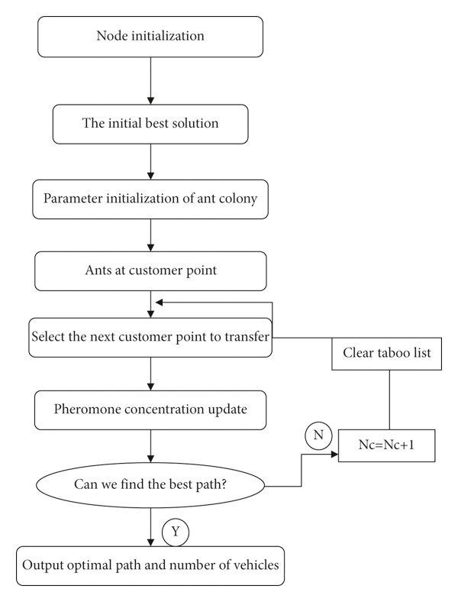

**NOTE:**

File Naming Convention: **TechnologyName_Phase3**

After completion upload your file to your **same private GitHub account** that has been created earlier. Please give access to your **college evaluators email ids.** Also please give access to faculty evaluator**[ facultyevaluator@gmail.com ]** and industry evaluator **[ IndustryEvaluator@skillup.online]** to your private GitHub repository for evaluation process.